_______________________________________________________________________________________________________________

SECTION 1: Identification of the substance/mixture and of the company/undertaking

  - Product identifier:

METHYL METHACRYLATE with DIMETHYL TOLUIDIN
Monomer mixture based on methacrylic acid esters (containing activator)

Substances
- Methyl methacrylate 60-100% (CAS 80-62-6)(EC 201-297-1)(REACH 01-2119452498-28)
- 2-Hydroxyethyl methacrylate 15-40% (CAS 868-77-9)(EC 212-782-2)(REACH 01-2119490169-29)
- N,N-Dimethyl-p-toluidine 1-5% (CAS 99-97-8)(EC 202-805-4)(REACH 01-2119937766-23)

Trade name / designation Methyl Methacrylate

Hazard components for labelling
- Methyl methacrylate 60-100%
- 2-Hydroxyethyl methacrylate 15-40%
- N,N-Dimethyl-p-toluidine 1-5%

  - Relevant identified uses of the substance or mixture and uses advised against
Relevant identified uses:
Adhesive in application of hoof care products

Uses advised against:
None known

1.3 Details of the supplier of the safety data sheet:

Supplier:
Giltspur Scientific Ltd
6-8 Avondale Industrial Estate
Ballyclare
Northern Ireland
BT39 9AU

+44 (0) 2893 322040
info@giltspurscientific.com

1.4 EMERGENCY TELEPHONE NUMBER:

Evonik Telephone - +49 61151 1801
Chemische Fabrik Emergency - +49 6151 18 4342
d-64275 Darmstadt

_______________________________________________________________________________________________________________

SECTION 2: Hazards identification

2.1. Classification of the substance or mixture:

Classification according to Regulation (EC) No 1272/2008 [CLP]
H225 Flam. Liq., H315 Skin Irrit., H317 Skin Sens.

Additional information:

Full text of H- phrases: see SECTION 16.

__________________________________________________________________________________________________________
  - Label elements

Labelling according to Regulation (EC) No 1272/2008 [CLP/GHS]
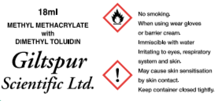

Hazard statements:
H225 Highly flammable liquid and vapour
H332 Harmful if inhaled
H312 Harmful in contact with skin
H302 Harmful if swallowed
H315 Causes skin irritation
H317 May cause an allergic skin reaction
H319 Causes serious eye irritation
H335 May cause respiratory irritation

Precautionary statements:
P210 Keep away from heat/sparks/open flames/hot surfaces — No smoking
P262 Do not get in eyes, on skin, or on clothing
P280 Wear protective gloves (or barrier cream) and eye protection
P281 Use personal protective equipment as required
P233 Keep container tightly closed
P260 Do not breathe vapours
P271 Use only outdoors or in a well-ventilated area
P285 In case of inadequate ventilation wear respiratory protection

______________________________________________________________________________________________________________

2.3 Other hazards

Polymerisation with heat evolution may occur in the presence of radical forming substances (eg peroxides), reducing substances, and/or heavy metal ions
___________________________________________________________________________________

SECTION 3. Composition/information on ingredients

3.1 Substances
Not applicable

3.2 Mixtures

Description of the mixture:
Solution of Methyl methacrylate, 2-Hydroxyethyl methacrylate and N,N-Dimethyl-p-toluidine

Hazardous ingredients

Substance name | CAS No. | EC No. | REACH No. | Concentration | Classification according  Regulation (EC) No. 1272 [CLP]
Methyl methacrylate  2-Hydroxyethyl methacrylate  N,N-Dimethyl-p-toluidine | 80-62-6  868-77-9  99-97-8 | 201-297-1  212-782-2  202-805-4 | 01-2119452498-28  01-2119490169-29  01-2119937766-23 | 60-100%  15-40%  1-5% | H225, H315, H317, H335, H370  H225, H302, H315, H317, H319, H335, H351  H301, H330, H331, H351, H373, H412

Additional information:
Full text of H-phrases: see SECTION 16.
_________________________________________________________________________________________________________________

SECTION 4: First aid measures

4.1 Description of first aid measures

General information
Remove soiled, soaked clothing immediately
Medical treatment is necessary if symptoms occur which are obviously caused by skin or eye contact with the product or by inhalation of its vapours.

Following inhalation
Remove the casualty into fresh air and keep him/her calm

Following skin contact
In case of contact with the skin wash off immediately with soap and water. If skin irritation occurs, seek medical attention.

Following eye contact
In case of contact with eyes rinse thoroughly with plenty of water and seek medical advice.

Following ingestion
Summon medical assistance immediately.

4.2 Most important symptoms and effects, both acute and delayed
Irritating to eyes, respiratory system and skin
May cause sensitisation by skin contact
Harmful by inhalation

  - Indication of any immediate medical attention and special treatment needed
Summon medical assistance immediately following ingestion
Medical treatment is necessary if symptoms occur which are obviously caused by skin or eye contact with the product or by inhalation of its vapours
____________________________________________________________________________________________________________________________

SECTION 5: Firefighting measures
5.1 Extinguishing media
Suitable extinguishing media
Foam
Dry powder
Carbon dioxide
Water SPRAY jet

Unsuitable extinguishing media
Do NOT extinguish with full water jet

5.2 Special hazards arising from the substance or mixture
May be released in case of fire: carbon monoxide, carbon dioxide, organic products of decomposition

5.3 Advice for fire-fighters
In the event of fire, cool the endangered containers with water.
Wear self-contained breathing apparatus.
Do not discharge into the drains/ surface waters/ ground water.
____________________________________________________________________________________________________________

SECTION 6: Accidental release measures

6.1 Personal precautions, protective equipment and emergency procedures

For non-emergency personnel
Ensure adequate ventilation
P284 Wear respiratory protection
P281 Use personal protective equipment as required

For emergency responders
Ensure adequate ventilation
P284 Wear respiratory protection
P281 Use personal protective equipment as required

  - Environmental precautions
Do not discharge into the drains/ surface waters/ ground water

  - Methods and material for containment and cleaning up
Larger quantities – remove mechanically (by pumping)
Smaller quantities and/or residues – absorb with absorbent material eg. sand or sawdust
Dispose of in accordance with regulations

6.4 Reference to other sections
For personal protection see section 8.
___________________________________________________________________________________________________________________________

SECTION 7: Handling and storage
7.1 Precautions for safe handling
P233 Keep containers tightly closed.
P271 Use only outdoors or in a well-ventilated area
P285 In case of inadequate ventilation wear respiratory protection
P210 Keep away from heat/sparks/open flames/hot surfaces — No smoking
P243 Take precautionary measures against static discharges
In the event of fire, cool the endangered containers with water

Advice on general occupational hygiene
Store work clothing separately
Remove soiled or soaked clothing immediately
Follow the usual good standards of occupational hygiene
_____________________________________________________________________________________________________________

7.2 Conditions for safe storage, including any incompatibilities
Keep only original container at a temperature not exceeding 30°C.
Fill the container by approximately 80% only, as oxygen (air) is required for stabilisation.
Keep out of light.

7.3 Specific end uses
Adhesive in application of hoof care products.
_______________________________________________________________________________________________________________

SECTION 8: Exposure controls/personal protection

  - Control parameters

Occupational exposure limits

-Methyl methacrylate
Long-term exposure limit (8-hour TWA):WEL 50ppm 208mg/m³
Short-term exposure limit (15-minute): WEL 100ppm 416mg/m³
*WEL= Workplace Exposure Limit*

DNEL Industry- Inhalation: 1.35mg/m³
Industry- Skin contact: 1.19mg/kg
Consumer- Inhalation: 0.34mg/m³
Consumer- Skin contact: 0.29mg/kg
Consumer- Ingestion: 2.37mg/kg

PNEC Fresh water; 0.153mg/l
Marine water; 0.0153mg/l
Soil; 18.68mg/kg dry weight
Fresh water sediment; 45.38mg/kg dry weight
Marine sediment; 45.38mg/kg dry weight
STP: 4.29mg/l

-N,N-Dimethyl-p-toluidine

DNEL Industry- Inhalation; Long term: 210mg/m³
Industry- Dermal; Long term: 13.67mg/kg/day
Industry- Dermal; Short term:1500mg/m³
Consumer- Inhalation; Long term: 74.3mg/m³
Consumer- Dermal; Long term: 8.2mg/kg/day
Consumer- Dermal; Short term: 1500mg/m³

PNEC Fresh water; 0.94mg/l
Marine water; 0.094mg/l
Soil; 1.47mg/kg
Sediment; 5.74mg/kg
STP: 10mg/l

- 2-Hydroxyethyl methacrylate
Data lacking.

______________________________________________________________________________________________________________

8.2 Exposure controls

Protective measures Do not inhale vapours
Avoid contact with eyes

Hygiene measures Store work clothing separately
Remove soiled or soaked clothing immediately
Follow the usual good standards of occupational hygiene

Respiratory Protection If ventilation insufficient, wear respiratory protection
Short term- filter apparatus, Filter A

Hand protection Rubber gloves

Eye protection Goggles

Body protection When handling larger quantities: face mask, rubber boots and rubber apron
__________________________________________________________________________________

SECTION 9. Physical and chemical properties

9.1 Information on basic physical and chemical properties
Physical state: Liquid
Colour: Colourless
Odour: Strong
Freezing point: below -25◦C
Boiling point: Not available
pH: Not available
Evaporation rate:
Flammability: Highly flammable
Upper/ lower flammability or explosive limits: Not available
Vapour pressure: Not available
Vapour density: Not available
Relative density: Not available
Solubility: Not available
Partition coefficient: Not available
Auto-ignition temperature: Not available
Decomposition temperature: Not available
Viscosity: Not available
Explosive properties: Not available
Oxidising properties: Not available
___________________________________________________________________________________

9.2 Other information:
Flash Point: +8ºC
Sustaining Combustion: Not available
_______________________________________________________________________________________________________________

SECTION 10: Stability and reactivity
10.1 Reactivity
Stable under normal conditions.
The following materials may react with the product: Acids. Azo, diazo, hydrazine comps. Alkalis. Oxidising materials.

10.2 Chemical stability
Stable at normal ambient temperatures and when used as recommended

10.3 Possibility of hazardous reactions
Polymerisation with heat evolution may occur in the presence of radical forming substances (eg peroxides), reducing substances, and/or heavy metal ions.

10.4 Conditions to avoid:
Avoid excessive heat for prolonged periods of time. Avoid flames and other sources of ignition.

10.5 Incompatible materials:
Materials to avoid: strong alkalis, strong acids, peroxides, strong oxidising agents.

10.6 Hazardous decomposition products:
Carbon oxides. Nitrogen oxides.
_______________________________________________________________________________________________________________

SECTION 11: Toxicological information
11.1 Information on toxicological effects

Inhalation: Vapours may irritate throat/ respiratory system. Symptoms following over exposure may include: headache, dizziness, drowsiness.
Ingestion: Gastrointestinal symptoms, including upset stomach.
Skin contact: Irritating to skin. May cause sensitisation by skin contact. Repeated exposure may cause skin dryness or cracking.
Eye contact: Irritating to eyes.
Target organs: Eyes, skin, respiratory system, lungs.

Acute toxicity- dermal (LD50mg/kg): data lacking
Acute toxicity- inhalation (LC50vapours mg/l): data lacking
Skin corrosion/ irritation (animal data): data lacking
Serious eye damage/ irritation: data lacking
Respiratory sensitisation: data lacking
Skin sensitisation: data lacking
Germ cell mutagenicity: data lacking
Carcinogenicity: data lacking
Reproductive toxicity: data lacking
Specific target organ toxicity- single exposure: data lacking
Specific target organ toxicity- repeated exposure: data lacking
Aspiration hazard: data lacking
______________________________________________________________________________________________________________
SECTION 12: Ecological information

An environmental hazard cannot be excluded in the event of unprofessional handling or disposal.
Harmful to aquatic life with long lasting effects.

12.1 Toxicity:
-Methyl methacrylate
Acute toxicity- fish: LC50 130 mg/l. Exposure time 96h. Species: Pimephales promelas (fathead minnow).
Acute toxicity- aquatic invertebrates: EC50 69 mg/l. Exposure time 48h. Species: Daphnia magna.
Acute toxicity- aquatic plants: 170 mg/l. Exposure time 96h. Species: Selenastrum capricornatum.

-N,N-Dimethyl-p-toluidine
Acute aquatic toxicity: Harmful to aquatic life
Chronic aquatic toxicity: Harmful to aquatic life with long lasting effects
Toxicity to fish: LC50: 46-52 mg/l. Exposure time 96h. Species: Pimephales promelas (fathead minnow).

- 2-Hydroxyethyl methacrylate
Data lacking.
__________________________________________________________________________________________________

12.2 Persistence and degradability

-Methyl methacrylate
Product is readily biodegradable

-N,N-Dimethyl-p-toluidine
No information available

- 2-Hydroxyethyl methacrylate
No information available
_______________________________________________________________________________________________________________

12.3 Bioaccumulative potential

-Methyl methacrylate
Bioaccumulation is unlikely to be significant because of the low water-solubility of this product.

-N,N-Dimethyl-p-toluidine
No information available

- 2-Hydroxyethyl methacrylate
No information available

12.4 Mobility in soil

-Methyl methacrylate
The product has poor water-solubility.

-N,N-Dimethyl-p-toluidine
No information available

- 2-Hydroxyethyl methacrylate
No information available

12.5 Results of PBT and vPvB assessment

-Methyl methacrylate
This product does not contain any substances classified as PBT or vPvB.

-N,N-Dimethyl-p-toluidine
This product does not contain any substances classified as PBT or vPvB.

- 2-Hydroxyethyl methacrylate
This product does not contain any substances classified as PBT or vPvB.

12.6 Other adverse effects:
Not determined.
_______________________________________________________________________________________________________________

SECTION 13: Disposal considerations
13.1 Waste treatment methods

Directive 2008/98/EC (Waste Framework Directive)
Hazardous waste according to Directive 2008/98/EC (waste framework directive).

Product
Waste is hazardous. It must be disposed of in accordance with the regulations after consultation of the competent local authorities and the disposal company in a suitable and licensed facility.

Contaminated packaging
Dispose of as unused product.

Other disposal recommendation
Do not discharge into the drains/ surface waters/ ground water.
___________________________________________________________________________________
SECTION 14: Transport information

 | Land transport (ADR/RID) | Inland waterway transport (ADN) | Sea transport (IMDG) | Air transport (ICAO-TI / IATA-DGR)
14.1 UN No. | UN1247 | UN1247 | UN1247 | UN1247
14.2 UN Proper shipping name | Methyl methacrylate monomer, stabilized | Methyl methacrylate monomer, stabilized | Methyl methacrylate monomer, stabilized | Methyl methacrylate monomer, stabilized
14.3 Transport hazard class(es) | 3 | 3 | 3 | 3
| Hazard label(s) | 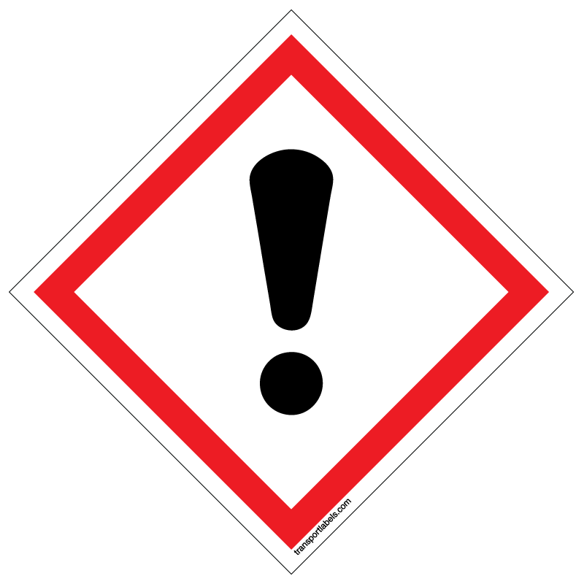    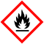 |  |  | 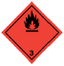  
14.4 Packing group | II | II | II | II
14.5 Environmental hazards | No | No | No | No

14.6 Special precautions for user
None known.

14.7 Transport in bulk according to Annex II of MARPOL 73/78 and the IBC Code
Additional information
Transported in limited quantities.
______________________________________________________________________________________________________________

SECTION 15: Regulatory information

15.1 Safety, health and environmental regulations/legislation specific for the substance or mixture

EU regulations
-Regulation (EC) No 1272/2008 of the European Parliament and of the Council of 16 December 2008 on classification, labelling and packaging of substances and mixtures (as amended).
-Regulation (EC) No 1907/2006 of the European Parliament and of the Council of 18 December 2006 concerning the Registration, Evaluation, Authorisation and Restriction of Chemicals (REACH) (as amended).

Guidance
-Safety Data Sheets for Substances and Preparations

  - Chemical Safety Assessment
No information available.
______________________________________________________________________________________________________________

SECTION 16: Other information
16.1 Indication of changes
NOTE: Lines within the margin will indicate significant changes from the previous revision

  - Key literature references and sources for data
Relevant manuals and publications
Existing SDS for substances contained in product

  - Relevant R-, H- and EUH-phrases (number and full text)

H225 Highly flammable liquid and vapour
H301 Toxic if swallowed
H302 Harmful if swallowed
H312 Harmful in contact with skin
H315 Causes skin irritation
H317 May cause an allergic skin reaction
H319 Causes serious eye irritation
H330 Fatal if inhaled
H331 Toxic if inhaled
H332 Harmful if inhaled
H335 May cause respiratory irritation
H351 Suspected of causing cancer
H370 Causes damage to organs
H373 May cause damage to organs through prolonged or repeated exposure
H412 Harmful to aquatic life with long lasting effects

  - Other Information
The information provided in this Safety Data Sheet is correct to the best of our knowledge, information and belief at the date of its publication. The information given is designed only as a guidance for safe handling, use, processing, storage, transportation, disposal and release and is not to be considered a warranty or quality specification.

